*Intel Unnati Industrial Training Program 2024*

*Team- Runtime Solvers*

*Problem Statement- Integrated Common Services to Common People*

*Kalinga Institute of Industrial Technology, Bhubaneswar*

*Intel Mentor- Debdyut Hazara*

*KIIT Mentor- Krishna Chakravarty*

*Team Members- Riya Malhotra (Lead) and Laxmirlola Behera*

Abstract

As technology is growing rapidly, most of the manual systems are being replaced and becoming automated. In this context, we are going to create an easy, faster and smooth appointment system between doctor and patient.

Though India is a developing country, a number of internet users are in here. So, through internet if people want to get connected to their desired doctors there is a nexus will be needed. For that purpose, we have planned to build a website to get an appointment. This will help common people to get instant support without wasting time and effort even they will get this service from home and abroad.

By using this system people can easily get to know about the timing of doctor's counselling period and make their meeting whenever they want. Proper categorized list will make people more comfort to browse their expected doctors.

Acknowledgement

This Project is our cordial effort and our supervisor's initiative and constant motivation. But first of all we would like to be grateful to the Almighty, who gives us the effort to work on this project. Special thanks go to our honorable Mentor Miss Krishna Chakarvarty. Her excellent supervision and constant support make this project possible. We are very grateful to him for giving us the opportunity to work with him.

Next, we must thank and acknowledge our university, Kalinga Institute of Industrial Technology, Deamed to be University.

Last but not least we thank our respectable parents for educating us, for their unconditional support and encouragement to pursue out interests, even when interests went out of boundary.

Problem Statement

Integrated Common Services to Common People revolutionizes the way essential public services are delivered, creating a seamless, unified platform that brings convenience and accessibility to all citizens. By integrating a wide array of government services—including healthcare, education, social security, and financial assistance—into a single, cohesive system, it ensures equitable access for every individual, regardless of socio-economic status. This initiative significantly enhances efficiency, transparency, and inclusivity, reducing bureaucratic hurdles and empowering citizens. By fostering a more connected and supportive society, Integrated Common Services to Common People stands as a transformative step towards a more equitable and progressive future for all.

Unique Idea Brief (Solution)

We here propose a doctor patient handling, managing system that helps doctors in their work and also patients to book doctor appointments. The system allows doctors to manage their booking slots online. Patients are allowed to book empty slots online and those slots are reserved in their name. The system manages the appointment data for the Doctor for various date and times. Each time a user visits a doctor his/her medical entry is stored in the database by doctor. Next time a user logs in he may view his/her medical history as and when needed. At the same time a doctor may view patients’ medical history when the patient visits him. Doctor Appointment System, as described above, can lead to error free, secure, reliable and fast management system. It can assist the user to concentrate on their other activities rather to concentrate on the record keeping. This allows for an automated patient doctor handling system through an online interface.

Objective and Goals

The objective of the system is to create a system where the process of a doctor appointment is made easy in both ways i.e. for the patients as well as the doctor.

Using this System Patients can book their appointment online at their own space and reach the doctor at their suitable time due to which they do not have to wait in long queue for their appointment. Also the appointment data will be stored in the database by the doctor, Due to this the time of the Patients will be saved and the patients will not have to carry previous reports of his appointments as the data are stored in the doctor database.

Scope and Limitations of Existing System

In the existing system, the records are gathered manually which significantly increase the cost and space to store the data.

Patients have to wait in long queues for their appointments.

At sometimes the doctor schedule may be full and some patients may not get the appointment even after travelling long distances to the doctor's clinic. Because the data is manually stored there is a high risk that the data is misplaced or lost from the books of the doctor, which can cost in losing some patients/clients. In the existing manual system the appointment time is more as compared to the proposed system due to manually writing the data on papers and many other reasons. The existing system can result in extra working time for the doctor which will disturb his day schedule. Due to written prescriptions and reports the patient has to carry their medical file every time they visit the doctor.

Features Offered

◆ **PATIENT**

➤ Register

➤ Login

View Profile

Book Appointment

➤ View Appointments

◆ **DOCTOR**

Login

View Profile

View Appointments

➤View Patient Profiles

◆ **ADMIN**

➤ Manage Appointments

➤ Manage Patients

Manage Doctors

Register Doctor

Proposed System:

The proposed project is a smart appointment booking system that provides patients or any user an easy way of booking a doctor’s appointment online. This is a web based application that overcomes the issue of managing and booking appointments according to user’s choice or demands. The task sometimes becomes very tedious for the compounder or doctor himself in manually allotting appointments for the users as per their availability. Hence this project offers an effective solution where users can view various booking slots available and select the preferred date and time. The already booked space will be marked yellow and will not be available for anyone else for the specified time. This system also allows users to cancel their booking anytime.

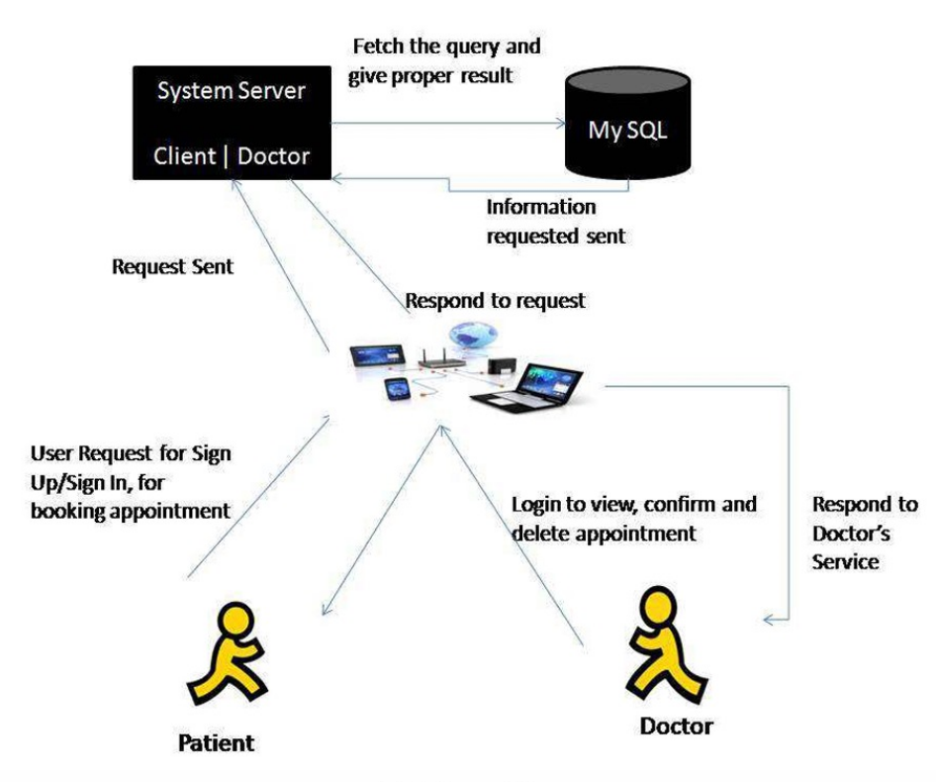

Process flow

STEP 1: REGISTRATION:-

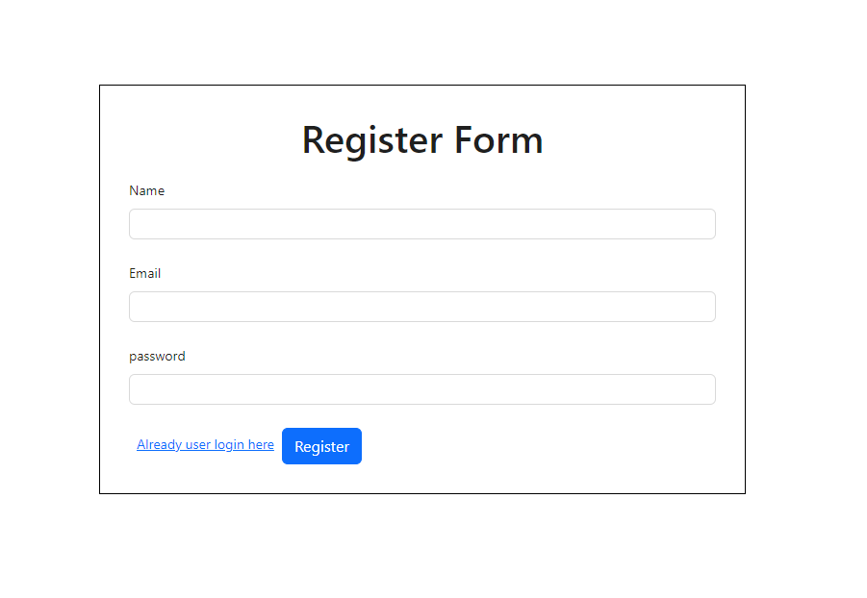

STEP 2 USER LOGIN:

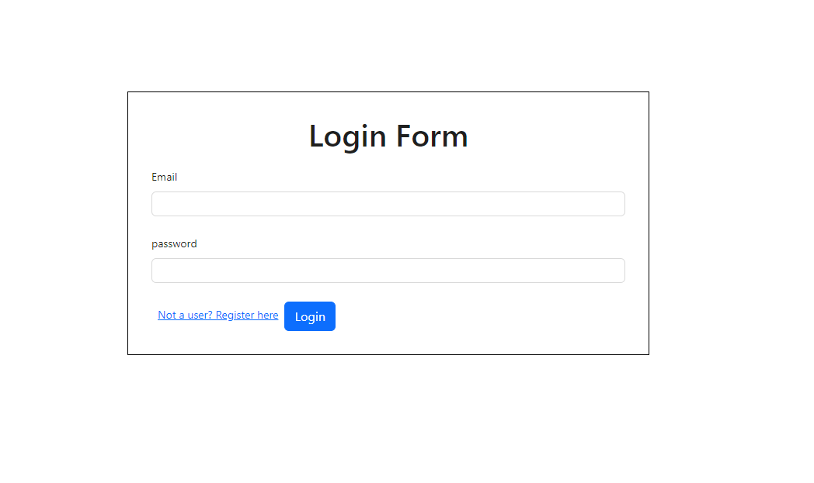

STEP 3: MAIN HOME PAGE

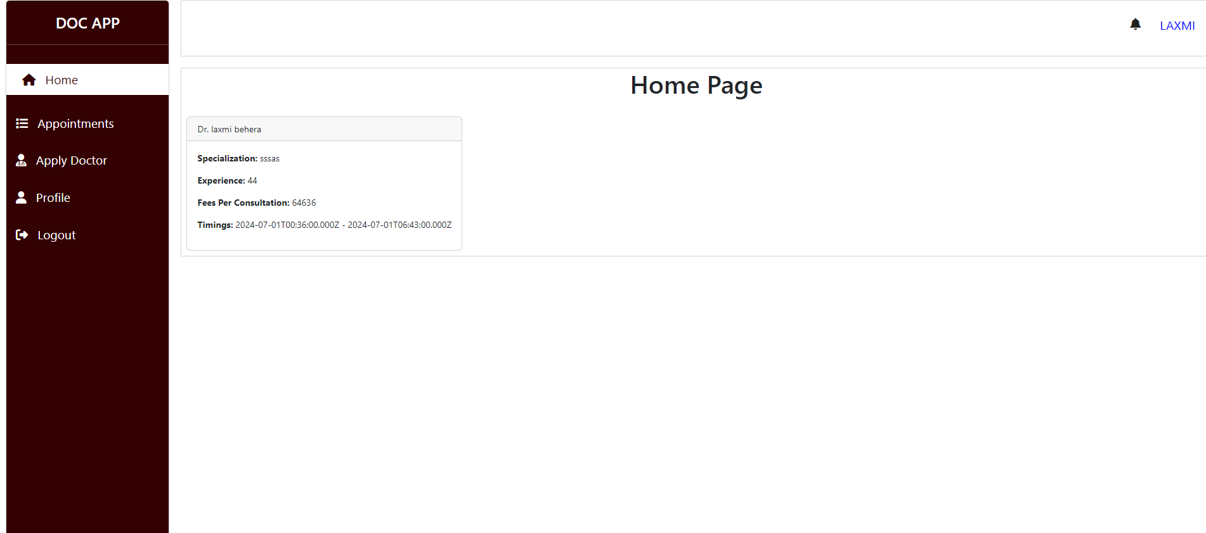

STEP 4: USER CAN VIEW APPOINTMENTS

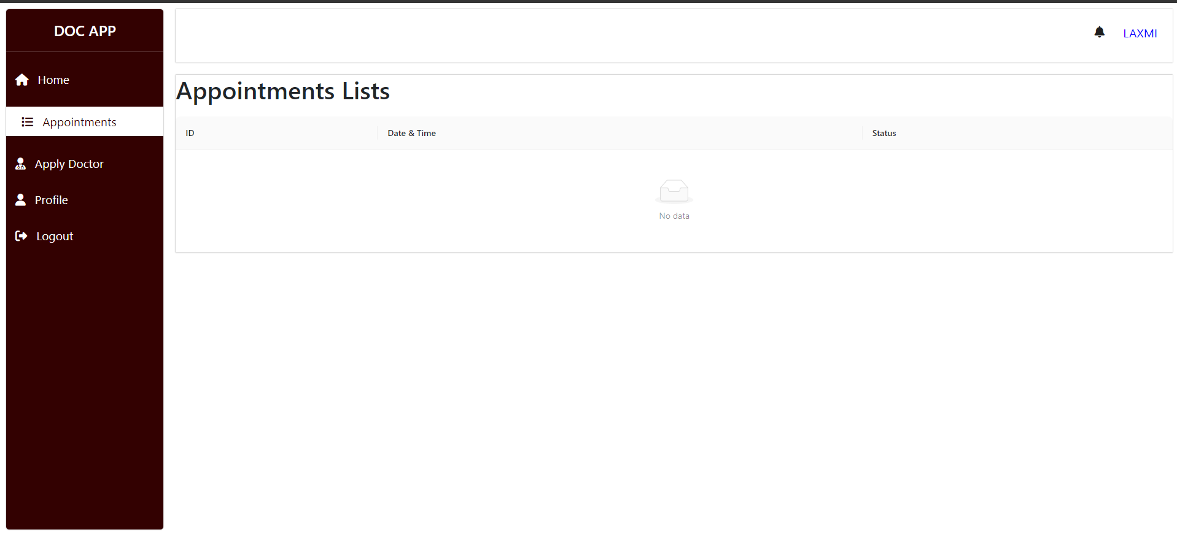

STEP 5: APPLY FOR DOCTOR

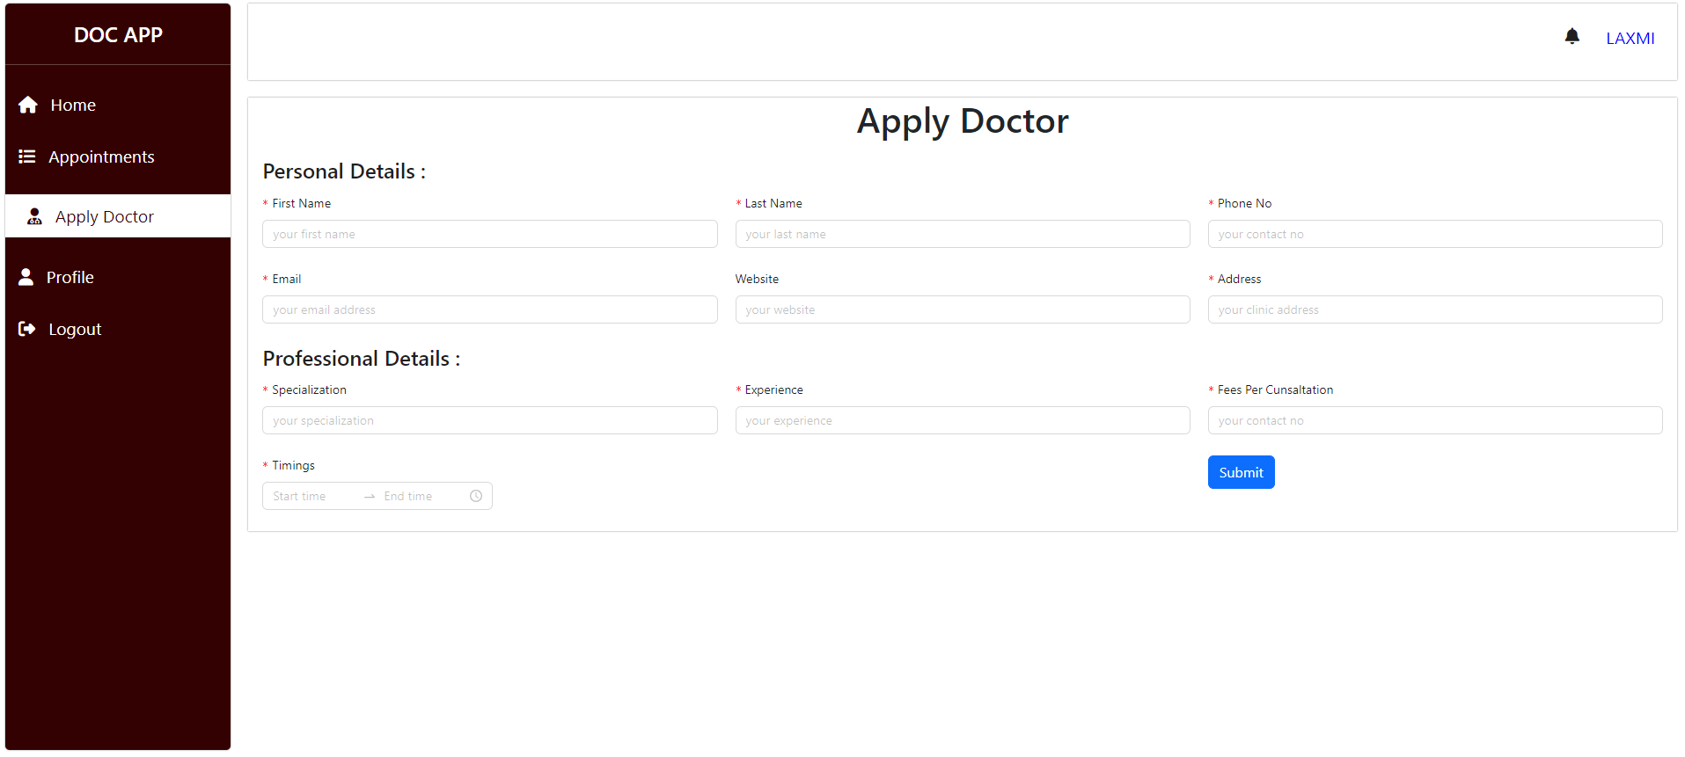

Architecture Diagram

The architecture is structured to allow users to make use of portable computer system, desktop computer system, and mobile phone as web browser to access the booking system. Client-server architecture was used and we used thin client-server. The medical appointment booking system has two components namely: the server-side and client-side that run on the browser. In the client approach almost all the processing work was done on demand at the server end and the client task was to display data and information on the screen. While in thin client-server architecture, the web browser is the client. This architecture was used because with it users will not be required to install any software on their PCs expect a standard web browser, which often come, with most PC operating system and almost all the current standard mobile phone. Clients would also not require any powerful PC; users can use any PC with a web browser such as laptop/notebook, mobile phone, and desktop PC. The servers would require higher configuration (in terms of hardware) because it would be regularly subjected to heavy load.

SYSTEM DESIGN:-

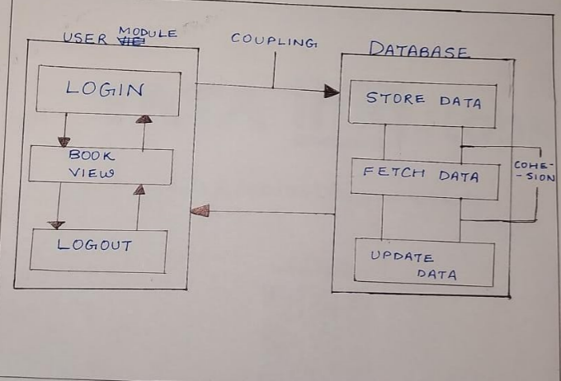

USE CASE DIAGRAM:-

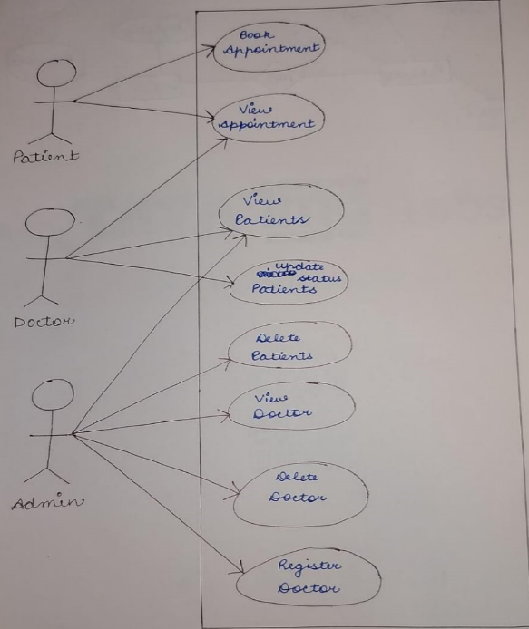

COMPONENTS DIAGRAM:-

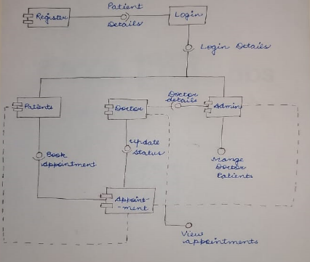

Technologies used

For building this web application, we have utilized the MERN stack, comprising MongoDB, Express.js, React, and Node.js.

* **React**: We used React to build a responsive and interactive user interface. React’s component-based architecture allowed us to create a dynamic and scalable front-end.
* **Express.js and Node.js**: On the back end, we leveraged Express.js and Node.js to handle server-side logic and API requests. This combination provides a robust and efficient framework for building and running server-side applications.
* **MongoDB**: We used MongoDB as our database to store real-time information for both users and doctors. MongoDB’s flexible schema and scalability make it an ideal choice for handling the diverse and dynamic data of our application.

Team members and contribution:

We, the Runtime Solvers team, are proud to present our web application, developed through the concerted efforts of two dedicated members: Riya Malhotra, our team lead, and Laxmirlola Behera. This project is a testament to our commitment and passion for technology and problem-solving.

From the outset, each team member has invested their complete effort and expertise to ensure the success of this project. Despite being beginners, we faced numerous challenges, ranging from technical errors to complex development hurdles. These obstacles, however, did not dampen our spirits. Instead, they fuelled our determination and reinforced our dedication to the project.

Our journey was marked by continuous learning and adaptation. Every error we encountered provided us with valuable lessons, and each difficulty we faced helped us grow stronger and more resilient. Through relentless hard work, perseverance, and a spirit of collaboration, we were able to overcome these challenges.

Our teamwork has been the cornerstone of our success. By leveraging each other’s strengths and supporting one another through the tough times, we have created a robust and efficient web application. This project stands as a testament to our collective effort, showcasing our ability to work together and achieve our goals despite the odds.

Our journey as Runtime Solvers has just begun, and we are excited about the many more successes to come.

Testing Implementation:

The purpose of this test to evaluate our system's compliance with the specified requirement.

We tried to make this system secured. Every single data that a user input on our system must pass the test.

TABLE 1: REGISTRATION AND LOGIN TEST CASE

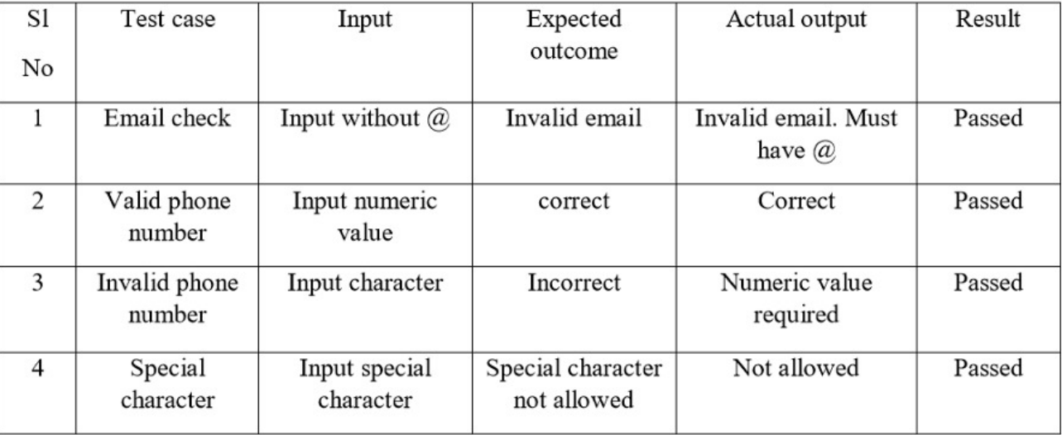

TABLE 2: INPUT USER INFORMATION TEST CASE

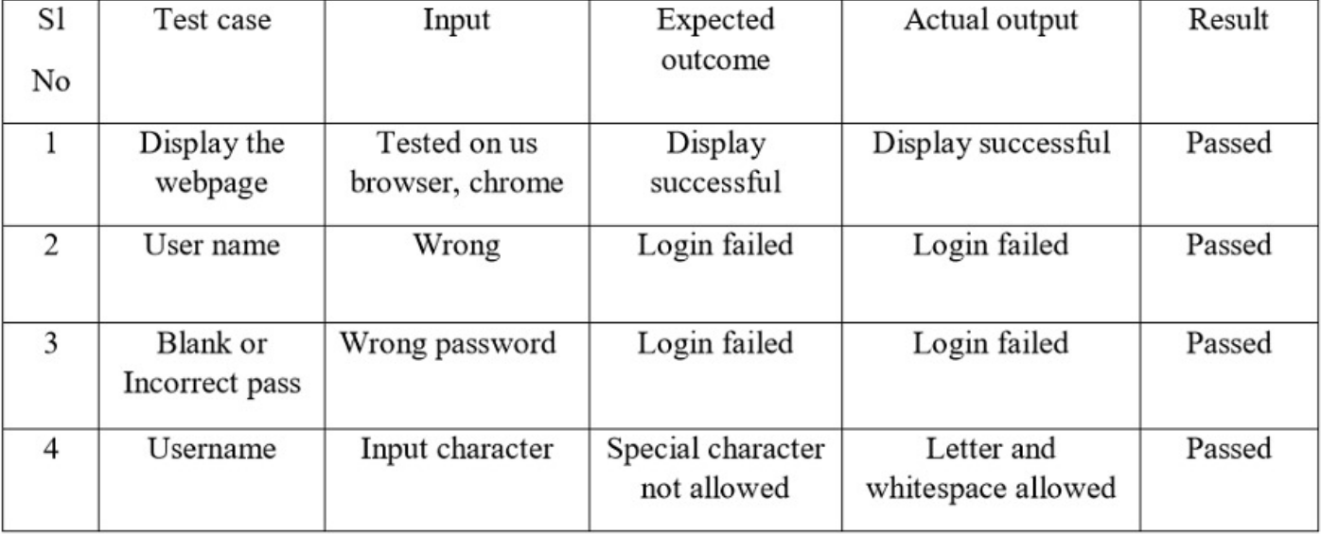

Scope of further Development:

Online system is always a changeable system. It develops day by day, getting better and better to easier for peoples. This could be a revolutionary web application that may help bonding between doctor and patient. We believe we can make this system more advanced in future.

Advance features and User interface will be updated in future. Our system is already user friendly but we will try to make this system more user-friendly in future.

Conclusion

Doctor and patient appointment system is a very exciting topic to work. After going through the work, we faced many challenging tasks. Day by day healthcare systems become an important part of our society. So we have decided to build this system.

We researched so many systems that showed us the direction how to develop our system. We interact with the people that what type of problem they facing. They were very happy to take this system as it is give them some relief in modern age.

Despite everything we achieved, we faced many challenges to finish this project. After all it's an online web-based system so in real life both doctor and patient need to follow the using rules otherwise its goal will be failed.